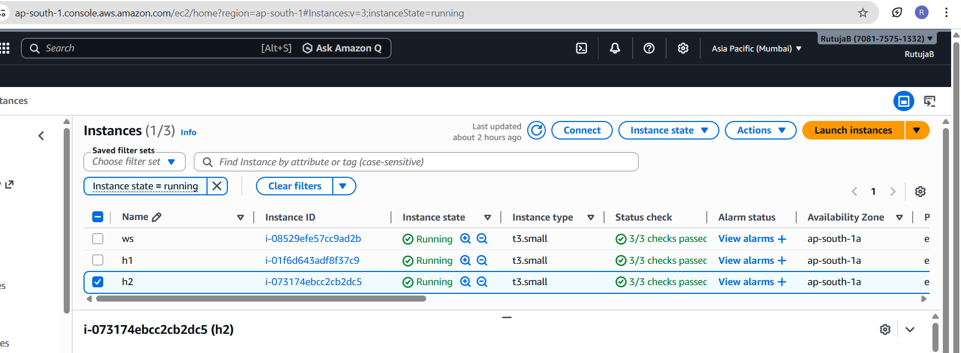
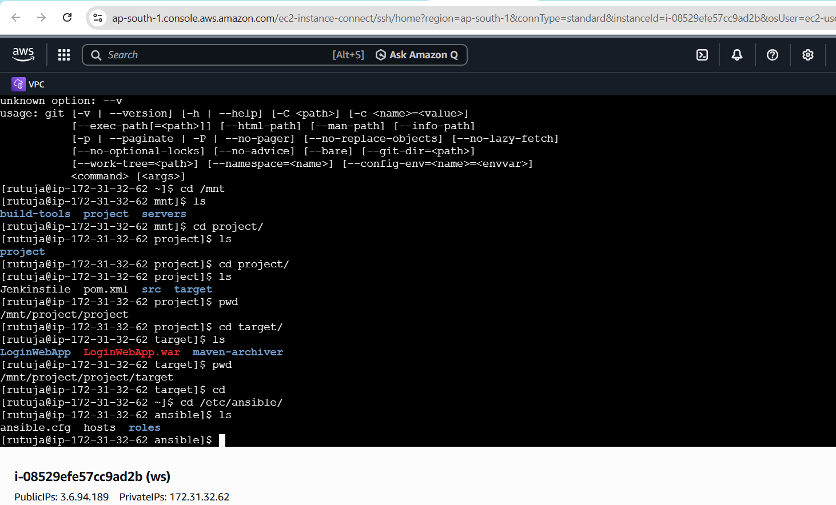
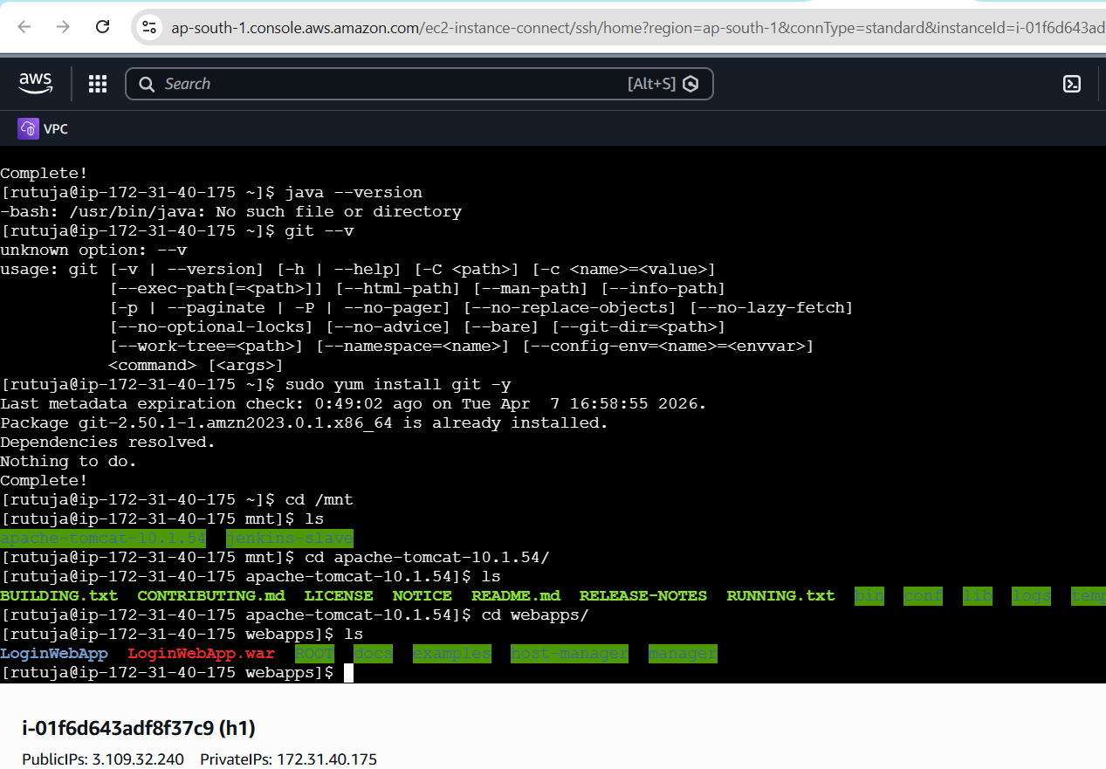
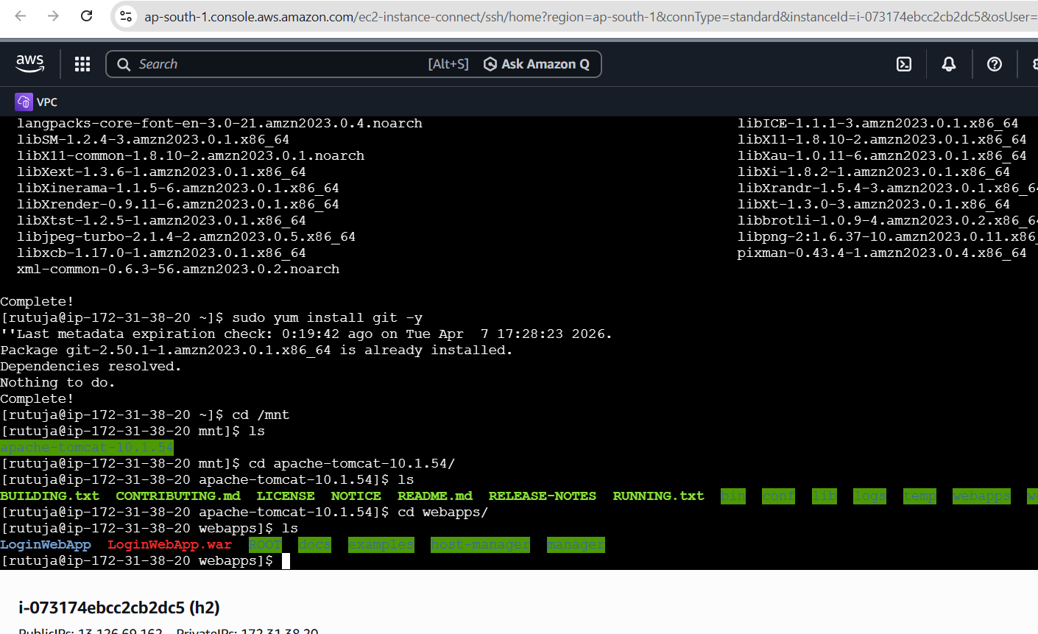
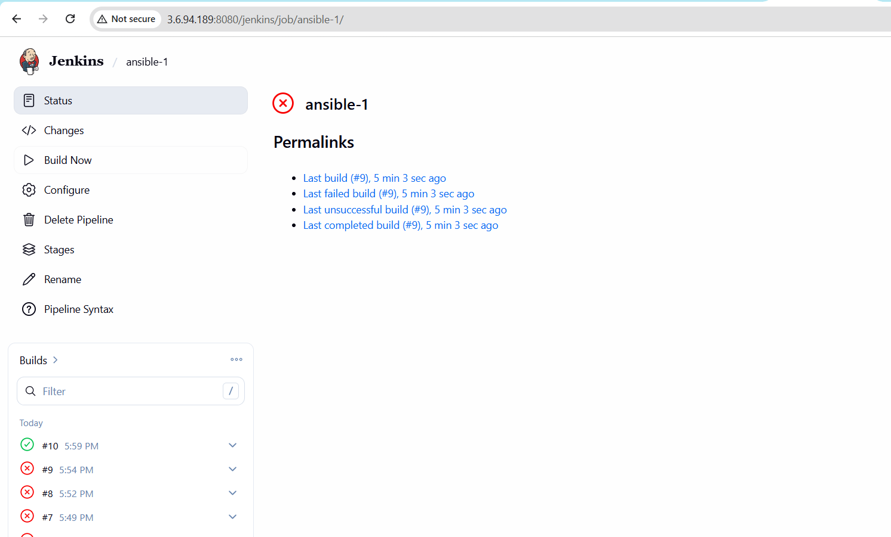
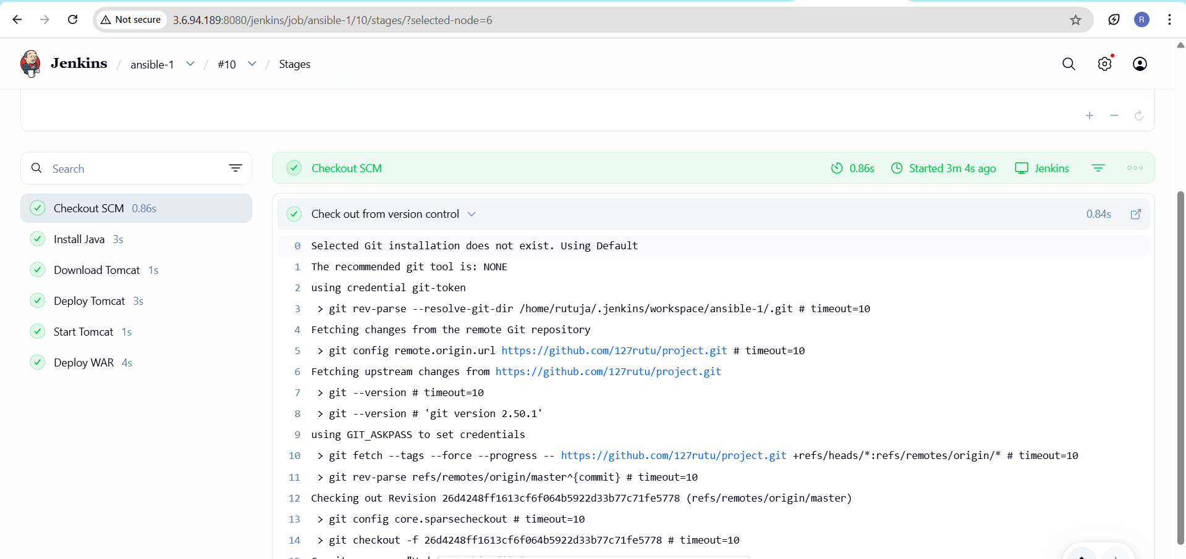
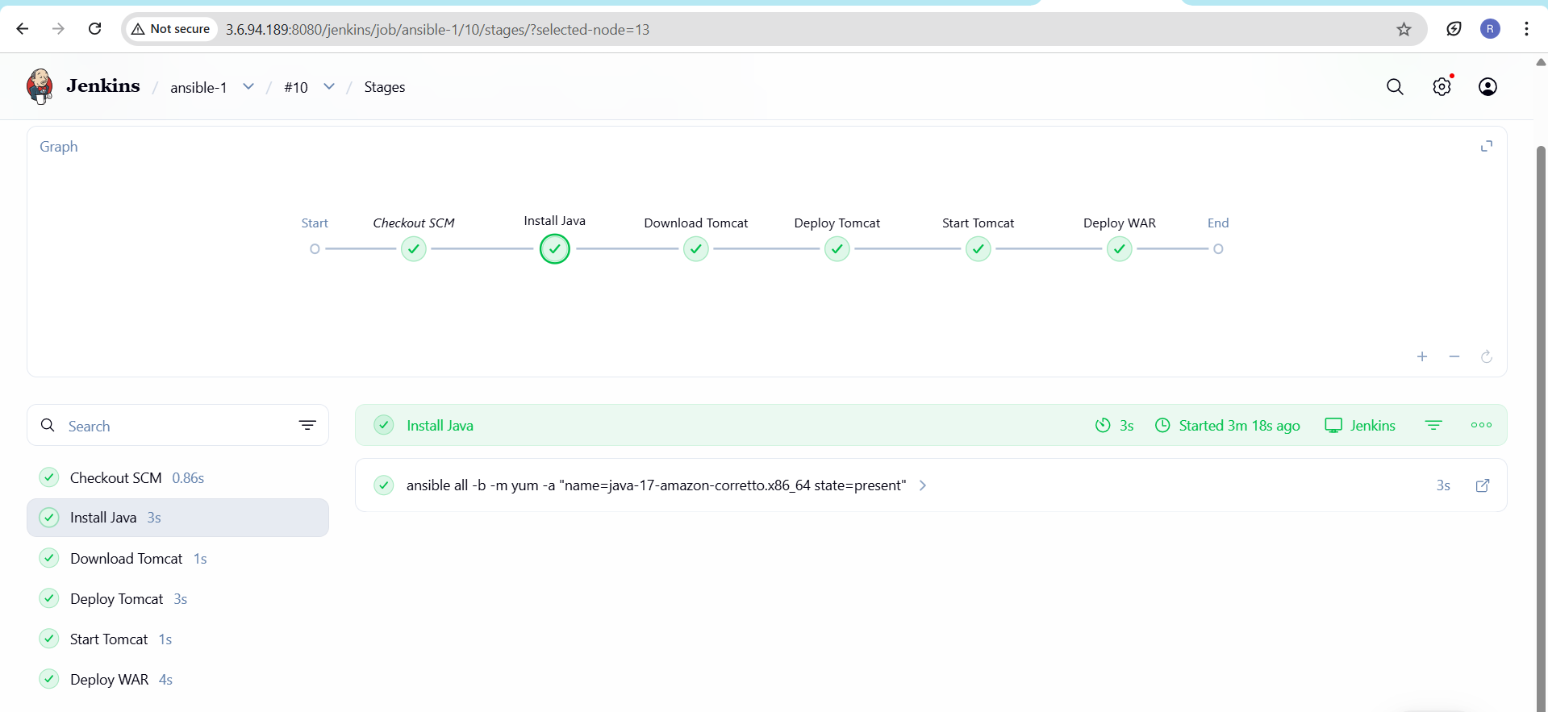
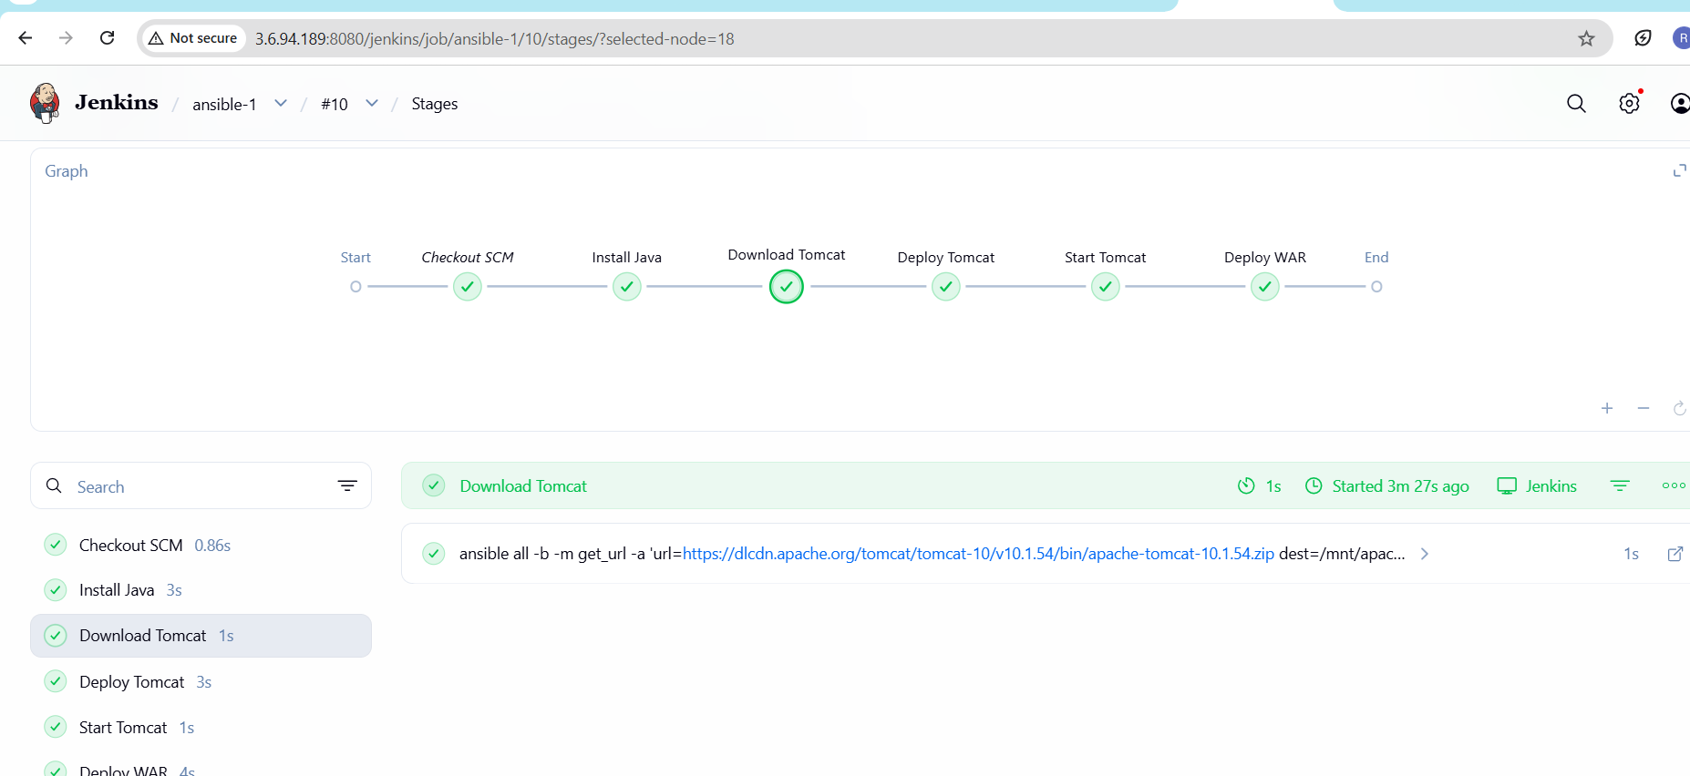
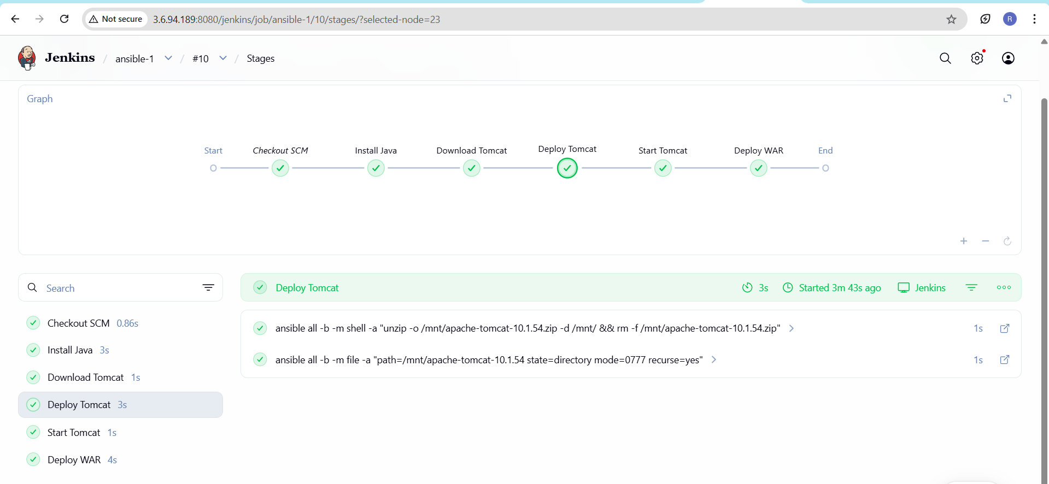
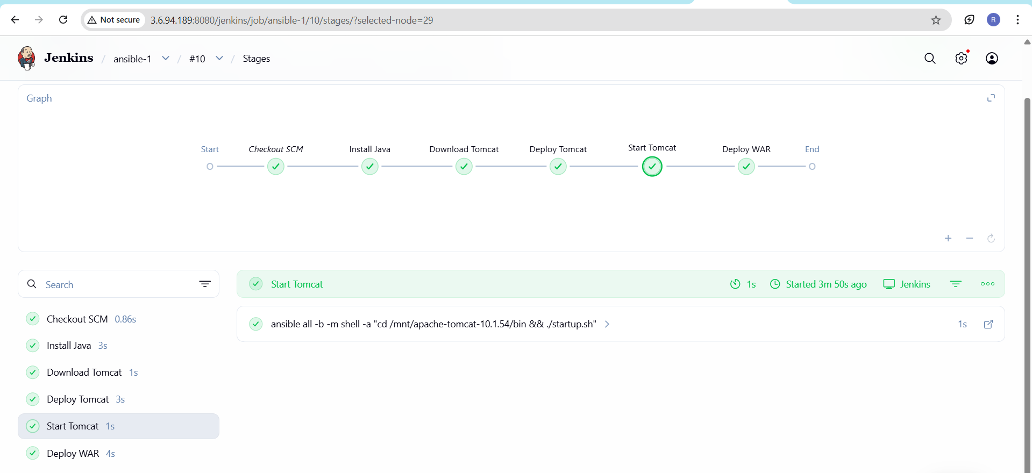
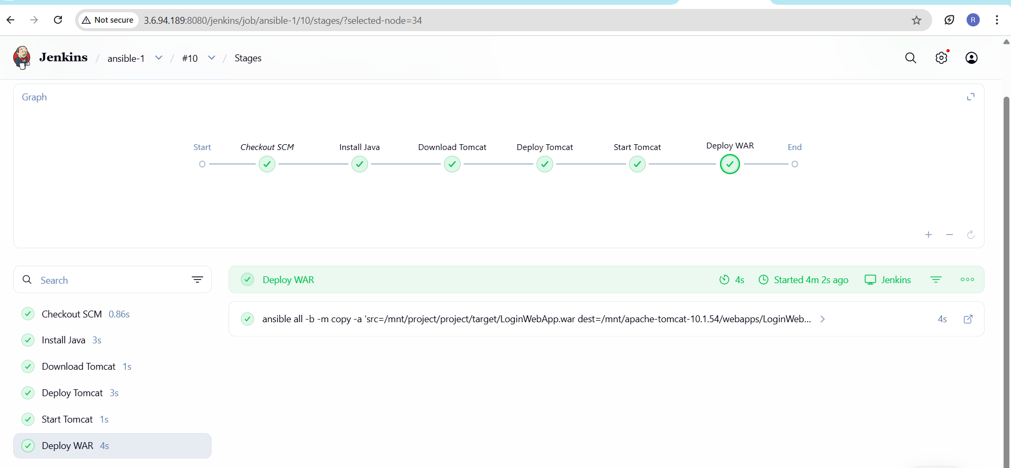
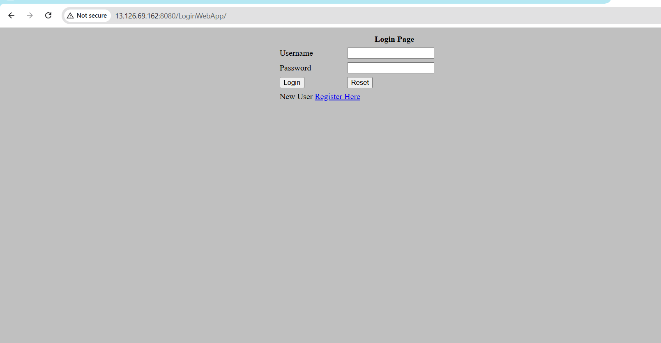

pipeline {
agent any

stages {

stage('Install Java') {
steps {
sh """
ansible all -b -m yum -a "name=java-17-amazon-corretto.x86_64 state=present"
"""
}
}

stage('Download Tomcat') {
steps {
sh """
ansible all -b -m get_url -a 'url=https://dlcdn.apache.org/tomcat/tomcat-10/v10.1.54/bin/apache-tomcat-10.1.54.zip dest=/mnt/apache-tomcat-10.1.54.zip'
"""
}
}

stage('Deploy Tomcat') {
steps {
sh """
ansible all -b -m shell -a "unzip -o /mnt/apache-tomcat-10.1.54.zip -d /mnt/ && rm -f /mnt/apache-tomcat-10.1.54.zip"
"""
sh """
ansible all -b -m file -a "path=/mnt/apache-tomcat-10.1.54 state=directory mode=0777 recurse=yes"
"""
}
}

stage('Start Tomcat') {
steps {
sh """
ansible all -b -m shell -a "cd /mnt/apache-tomcat-10.1.54/bin && ./startup.sh"
"""
}
}

stage('Deploy WAR') {
steps {
sh """
ansible all -b -m copy -a 'src=/mnt/project/project/target/LoginWebApp.war dest=/mnt/apache-tomcat-10.1.54/webapps/LoginWebApp.war mode=0644'
ansible all -b -m shell -a 'cd /mnt/apache-tomcat-10.1.54/bin && ./shutdown.sh && ./startup.sh'
"""
}
}
}
}

